Common bile duct

Formation
By union of common hepatic duct and cystic duct

Drainage
Drains bile into second part of duodenum at Ampulla of Vater (located at major duodenal papilla)
Along with Pancreatic duct
Guarded by sphincter of Boyden

Dimensions
Usually 7 - 8 cms in length
In adults < 8 mm in diameter

Parts
Supra - duodenal part
Retro - duodenal part
Infra - duodenal part (retropancreatic)
Intra - duodenal part
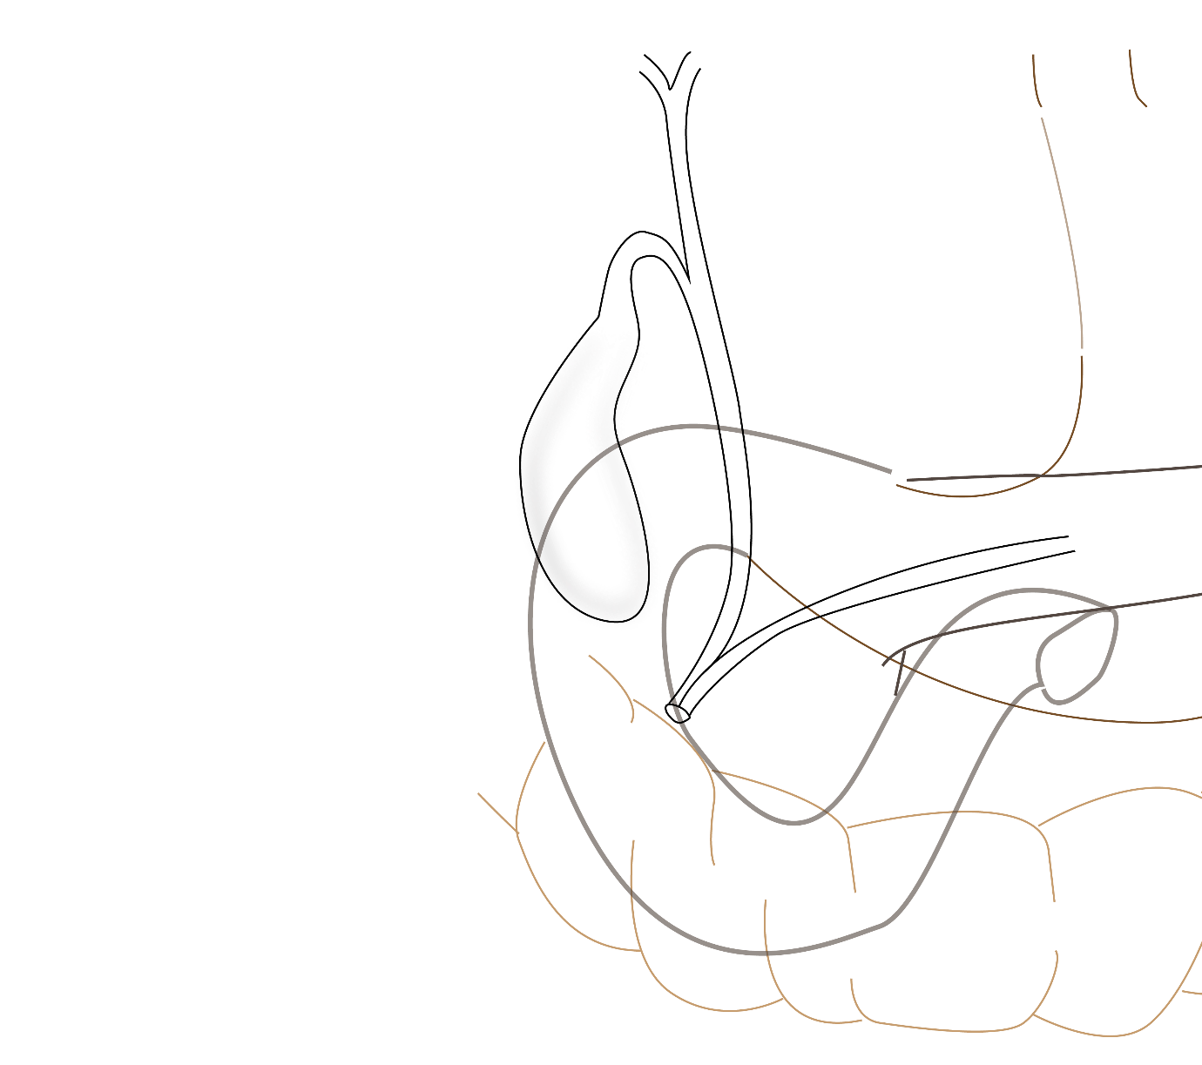

Supra - duodenal part
- From confluence of right and left hepatic ducts upto the upper border of first part of duodenum
- Descends in the free margin of lesser omentum
- Located on the right of hepatic artery
- It is anterior to portal vein

Retro - duodenal part
- Located behind the first part of duodenum
- Along with gastroduodenal artery
- IVC is posterior to it

Infra - duodenal (pancreatic) part
- Occationally embedded in pancreas
- Located just anterior to IVC
- Gastroduodenal artery gives superior pancreatico-duodenal artery branch in relation to this part
- Superior pancreatico-duodenal artery crosses CBD
- CBD touches pancreatic duct

Intra-duodenal (intramural) part
- CBD enters middle of second part of duodenum along with pancreatic duct
- Ampulla of Vater - bulges into the mucosa of duodenum at major duodenal papilla
- Guarded by sphincter of Boyden

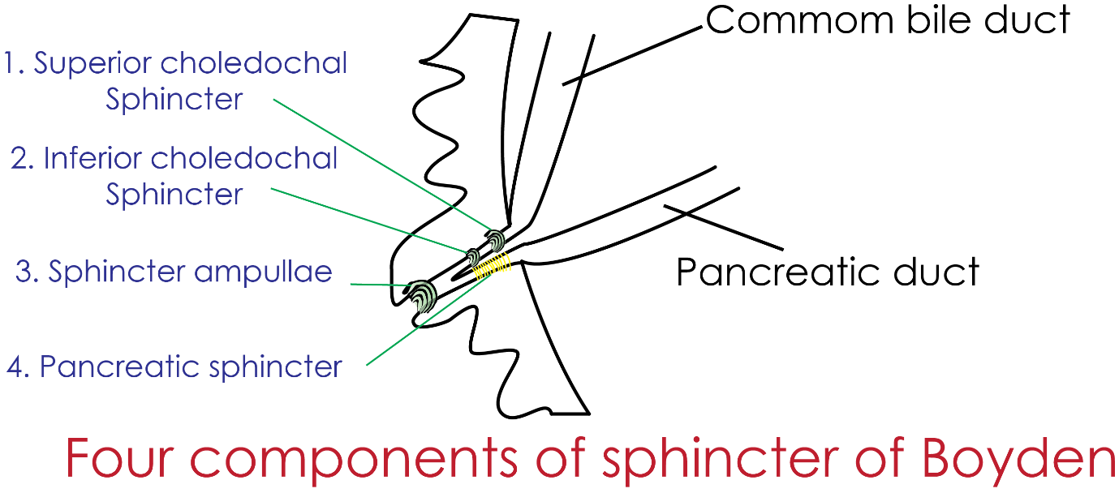

Blood supply of common bile duct
Upper part - cystic artery
Lower part - ascending marginal vessels derived from the postero-superior pancreaticoduodenal artery.

Clinical significance - imaging of Commonbile duct
- Endoscopic retrograde cholangiopancreaticography is considered the gold standard for imaging of CBD
- Endoscopic ultrasound
- Computed Tomographic (CT) cholangiography
- Abdominal T2-weighted or intravenously administered contrast material–enhanced MR imaging

Clinical significance – Choledocholithiasis
- Presence of a gallstone in the common bile duct
- Stone in the CBD can cause biliary obstruction, inflammation of bile duct(cholangitis), inflammation of pancreas (pancreatitis).
- Long standing obstruction may lead to secondary biliary cirrhosis.
- More than 10% of the patients with gall bladder stones have concomitant CBD stones.

Imaging technique
Endoscopic Retrograde Cholangiopancreatography
Technique of endoscopy where the probe is navigated through the sphincter in the duodenal wall into the common bile duct and dye is injected
Bile tree is visualised

